1. Use Selenium WebDriver or Katalon Recorder to automate selecting your favorite IPL team from a dropdown menu on a sample sports fan signup form.
Ans:
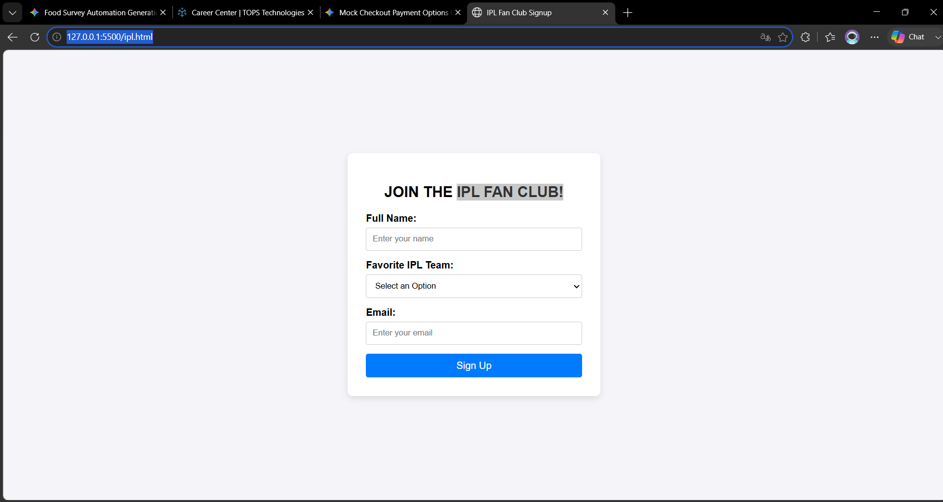

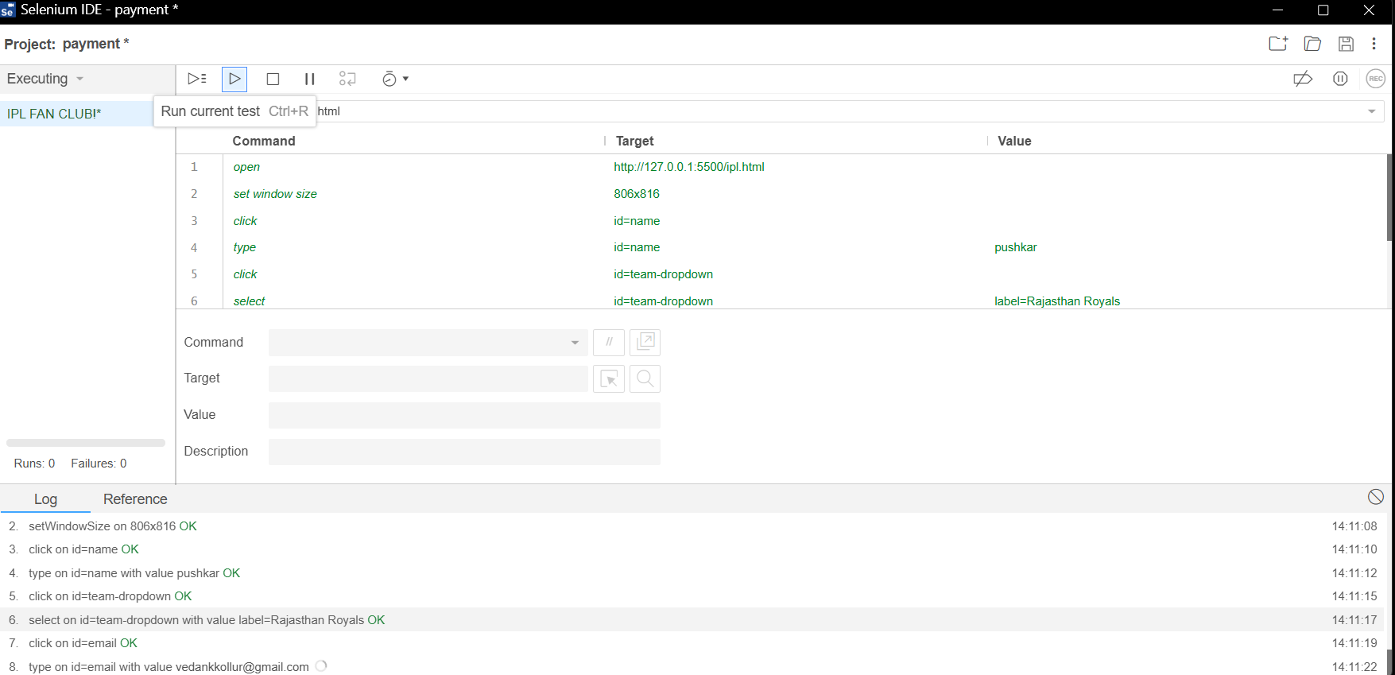

2. Write an automation script that checks and unchecks multiple cuisine options (e.g., Pizza, Burger, Biryani) in a food delivery app-style form using Selenium or Katalon Recorder.
Ans:
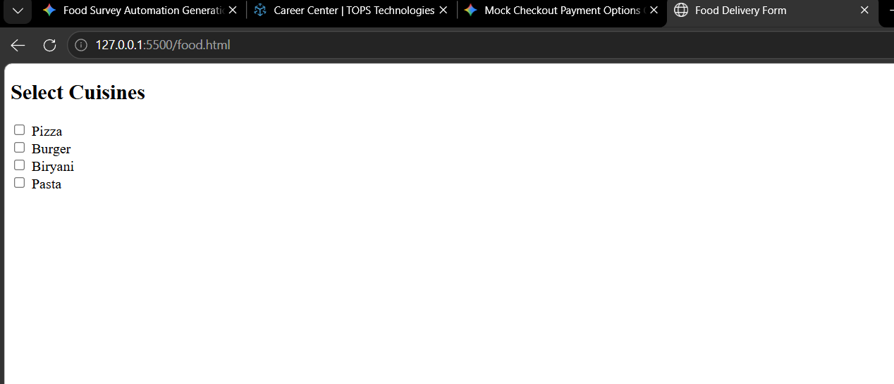

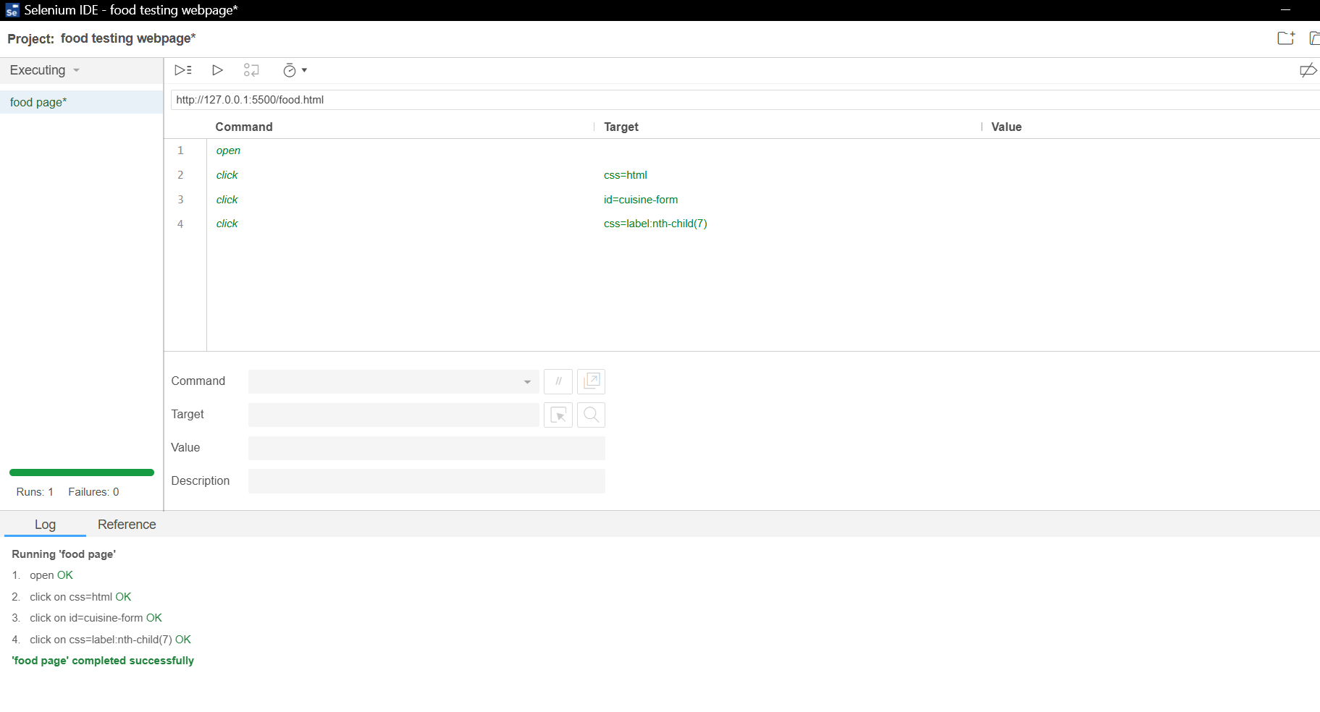

3. Automate the process of selecting a payment method (UPI, Card, Wallet) using radio buttons on a mock checkout page and verify the correct option is selected.
Ans:
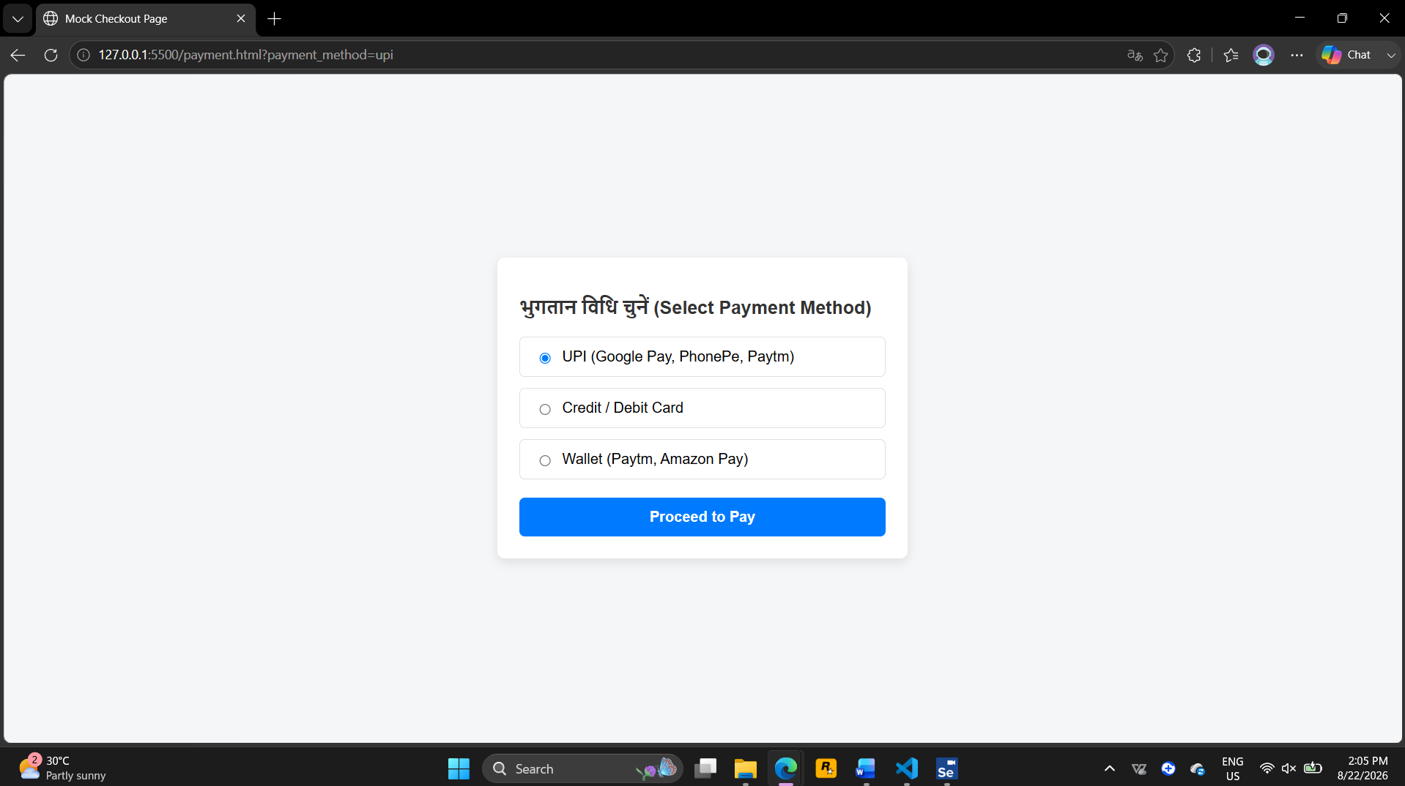
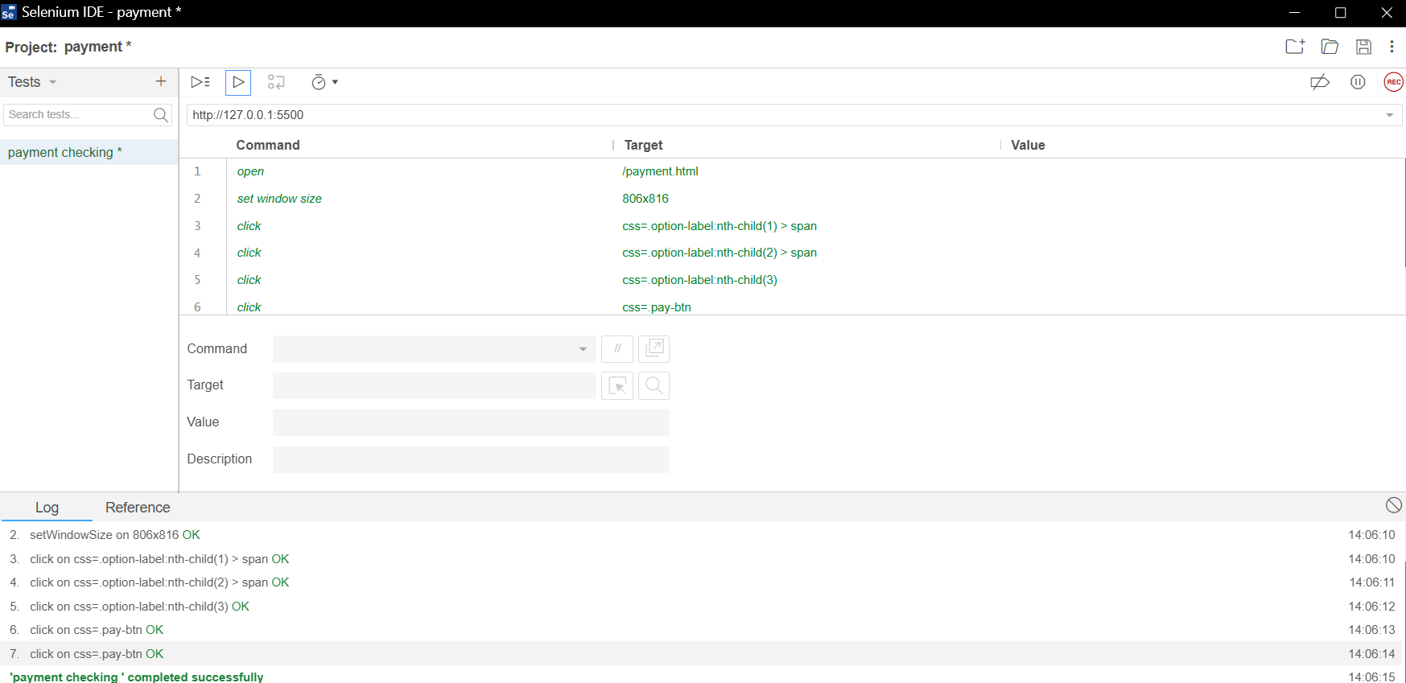

4. Create a Selenium or Katalon Recorder script to pick a specific date (e.g., your birthday) from a date picker in a movie ticket booking form.
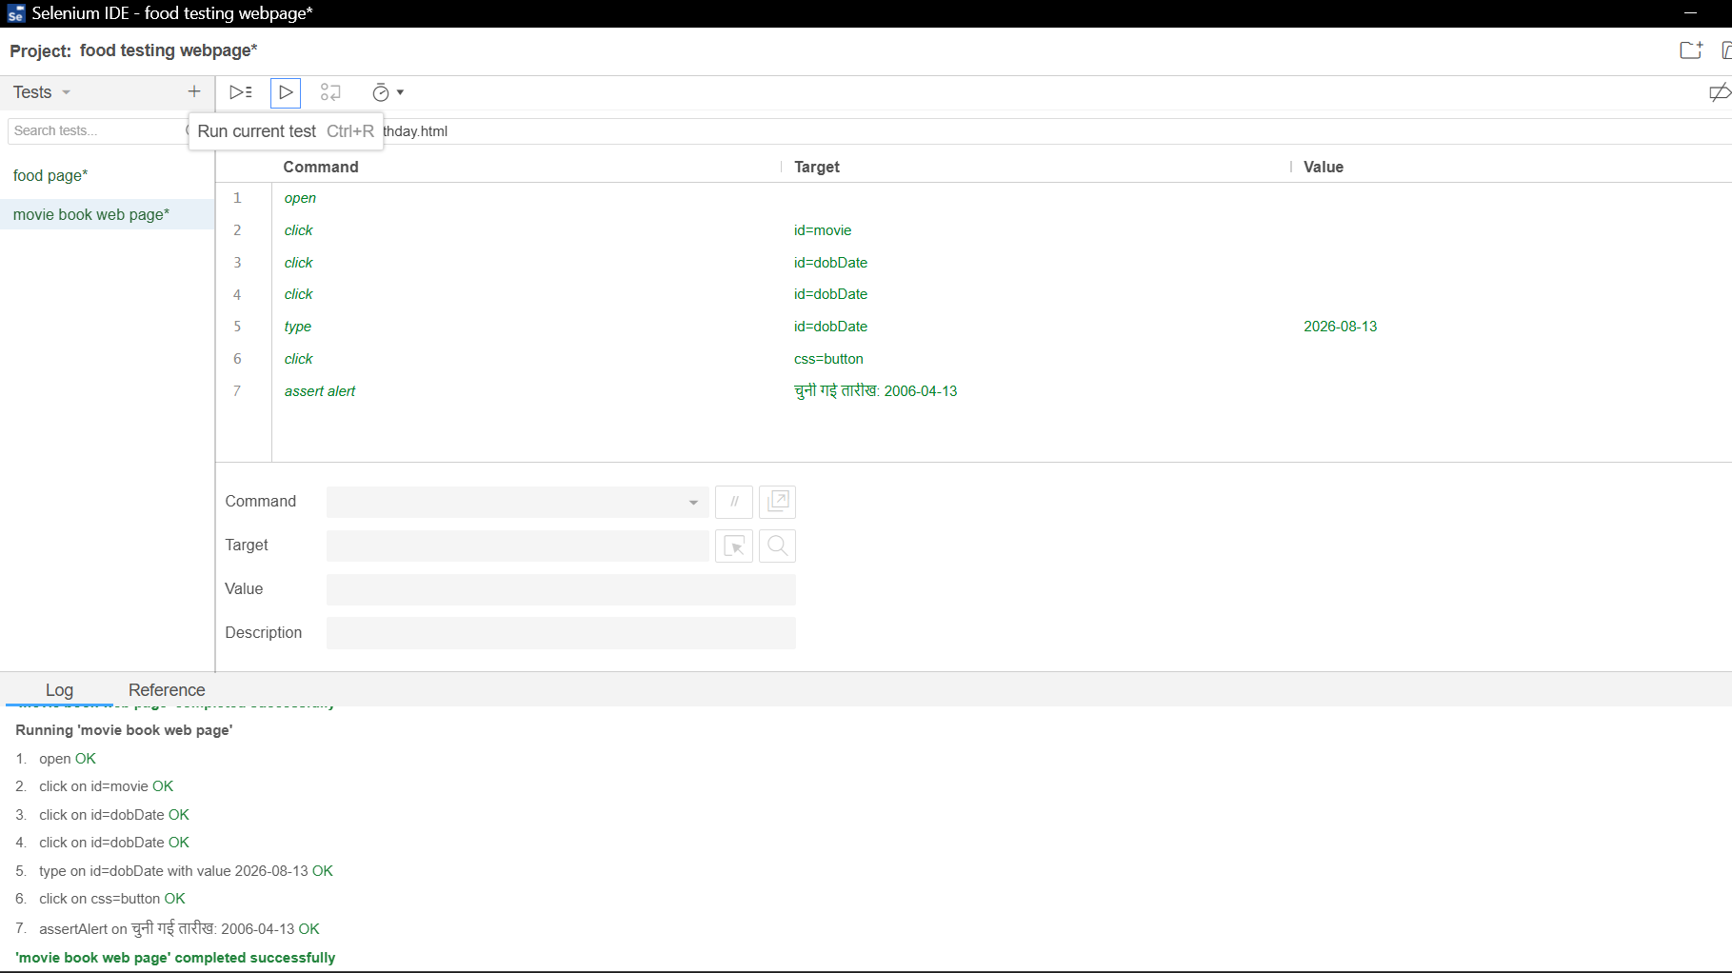
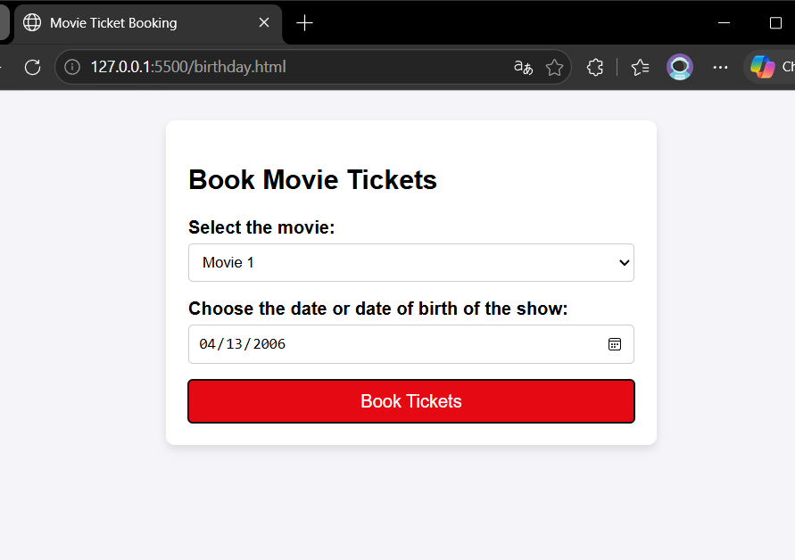

5. Automate entering a city name in a search box with auto-suggestions (like Zomato), select the second suggestion, and verify the correct value is entered.Use Selenium's sendKeys() to type and then select from the suggestion list using arrow keys or by locating the suggestion element.
Ans:
